**Lección 7.1 / Gramática**

¿Qué productos necesitas?

A. B. C. D. E. F.

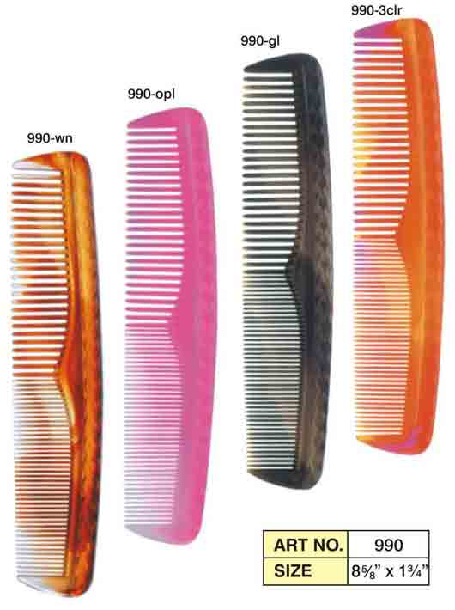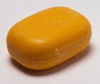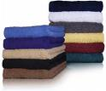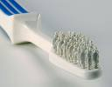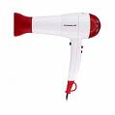

1. ________ lavarse la cabeza 4. ________ lavarse la cara

2. ________ cepillarse los dientes 5. ________ peinarse

3. ________ secarse 6. ________ secarse el pelo

**I. Describing Actions That Involve Oneself: Reflexive Verbs**

Escribe los verbos reflexivos en español.

1. to wake up __________________________________ 8. to dry oneself _____________________________

2. to get up __________________________________ 9. to get dressed _____________________________

3. to take a shower __________________________________ 10. to comb one’ s hair _____________________________

4. to take a bath __________________________________ 11. to put on makeup _____________________________

5. to wash one’s hair __________________________________ 12. to wash oneself _____________________________

6. to shave oneself __________________________________ 13. to go to bed _____________________________

7. to brush one’s teeth __________________________________ 14. to fall asleep _____________________________

1. ¿Para qué usas los verbos reflexivos?

|  |  |  |  |
| --- | --- | --- | --- |
| **singular** | **plural** | **los singulares en inglés** | **los plurales en inglés** |
|  |  |  |  |
|  |  |  |  |
|  |  |  |  |

Escribe **los pronombres reflexivos** en español.

3. Si no usas un pronombre reflexivo, ¿es un verbo reflexivo?

*¿Tienes algunas preguntas?

Escribe una tabla para cada verbo reflexivo. Incluye los pronombres personales, los pronombres reflexivos y la forma adecuada del verbo conjugado. ¡Recuerda que el pronombre reflexivo va delante del verbo conjugado!

1. acostarse(ue) ______ ______ ____________________ ______ ______ ____________________

______ ______ ____________________ ______ ______ ____________________

______ ______ ____________________ ______ ______ ____________________

2. afeitarse ______ ______ ____________________ ______ ______ ____________________

______ ______ ____________________ ______ ______ ____________________

______ ______ ____________________ ______ ______ ____________________

(Desde este punto no tienes que incluir los pronombres personales.)

3. despertarse (ie) ______ ____________________ ______ ____________________

______ ____________________ ______ ____________________

______ ____________________ ______ ____________________

4. dormirse (ue) ______ ____________________ ______ ____________________

______ ____________________ ______ ____________________

______ ____________________ ______ ____________________

5. lavarse ______ ____________________ ______ ____________________

______ ____________________ ______ ____________________

______ ____________________ ______ ____________________

6. ponerse ______ ____________________ ______ ____________________

______ ____________________ ______ ____________________

______ ____________________ ______ ____________________

7. secarse ______ ____________________ ______ ____________________

______ ____________________ ______ ____________________

______ ____________________ ______ ____________________

¿Dónde pones el pronombre reflexivo en una oración cuando sólo hay un verbo conjugado?

___________________________________________________________________________________

*In a sentence, when a reflexive pronoun is used with a verb, possession is automatically being shown. In front of the object of the verb, do not use a possessive adjective. It would be repetitious. Use articles in front of the objects.

modelo: Me lavo **las** manos. = I wash **my** hands.

explanation: (The hands have to be my hands, because the reflexive verb accompanied by the reflexive pronoun, me, sending the action of the verb back to the speaker, yo. They could not possibly be anyone else’s hands.)

modelo: Sergio se pone **la** gorra. = Sergio puts on **his** baseball cap.

explanation: (The baseball cap has to be Sergio’s, because the reflexive pronoun, se, sends the action of the verb back to the speaker, Sergio.)

Escribe bien en español estas oraciones.

1. I wash my face with soap two times each day.

2. I brush my teeth with a toothbrush.

3. I take a shower one time every day.

4. We wash our hair with excellent shampoo!

5. Are you (familiar) drying your hair with a hairdryer?

6. He is shaving his face with a mirror!

**Usa las siguientes palabras para completar el párrafo. (Hint: Complete the paragraph)**

***Me baño me levanto afeitarse se despiertan***

***me pongo se maquilla levantarme***

El despertador suena a las seis y media, pero yo nunca quiero ________________________ a esa hora. Duermo un poco más y _____________________ a las siete menos cuarto. ____________________ y _______________________ la ropa y voy a la cocina a comer algo. Mis padres _____________________________ un poco más tarde que yo, a las siete o las siete y cuarto. Ellos tienen dos espejos en su baño porque papá se mira en el espejo para ________________________ al mismo tiempo que mamá ________________________.

¿Dónde pones el pronombre reflexivo en una oración cuando hay un verbo conjugado más un infinitivo?

a. _______________________________________________________________________________________

b. _______________________________________________________________________________________

Escribe las oraciones en español. Write each sentence in two ways.

1. I need to wash my hair right now!

________________________________________________________________________________________________

________________________________________________________________________________________________

2. We want to brush our teeth too much!

________________________________________________________________________________________________

________________________________________________________________________________________________

3. Do you (formal) need to take a shower?

_________________________________________________________________________________________________

_________________________________________________________________________________________________

**===========================================================**

**¡Algo para apuntar! -** ¡Estos tres verbos tienen sentidos diferentes cuando los usas como reflexivos!

|  |  |
| --- | --- |
| **Verbos normales:** | **Verbos reflexivos:** |
| 1. dormir (ue) = to sleep | 1. dormir**se** (ue) = to **fall** asleep |
| 2. ir = to go | 2. ir**se** = to **leave**, to go **away** |
| 3. poner = to put | 3. poner**se** = to put **on** (clothing etc.) |

Escribe en español.

1. I like to sleep, but I am not falling asleep right now.

2. Are you (familiar) leaving today?

3. Sofía has just put on a jacket, and she is putting the towels in the bathroom.