Las celebraciones y los postres
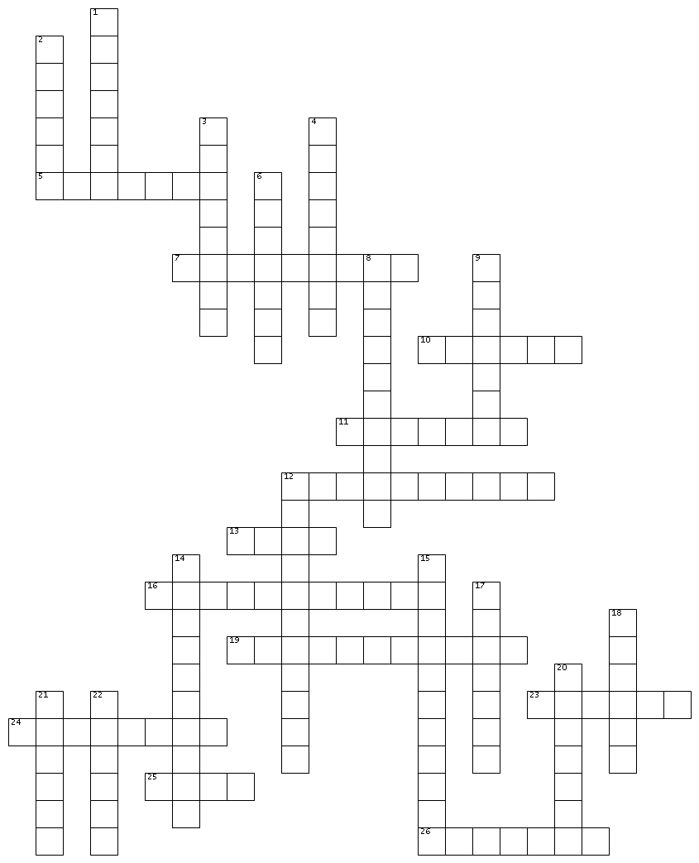

ACROSS
5. to smile
7. to relax
10. party
11. to invite
12. to have fun
13. baked custard
16. Sweet 15
19. anniversary
23. cake
24. to celebrate
25. wedding
26. Christmas
DOWN
1. champagne
2. candy
3. surprise
4. guest
6. to give
8. to surprise
9. bottle
12. holiday
14. birthday
15. to have a good time
17. to toast
18. dessert
20. cookie
21. to laugh
22. ice cream

