Español 1 Nombre:________________
Lección 2 Fecha:__________ Clase:___
Repaso: Prueba de vocabulario
I – Translate the words.
- el examen _______________________ 11. la economía _______________________
- la pizarra _______________________ 12. el lápiz _______________________
- el lunes _______________________ 13. la casa _______________________
- las matemáticas_______________________ 14. la tiza _______________________
- la cafetería _______________________ 15. el cuaderno _______________________
- la tarea _______________________ 16. la biblioteca _______________________
- el borrador _______________________ 17. el papel _______________________
- el sábado _______________________ 18. la prueba _______________________
- la historia _______________________ 19. la librería _______________________
- la calculadora _______________________ 20. el miércoles _______________________

II – Tell the “materia” for each topic.
- mapas _______________________ 6. números _______________________
- Frida Kahlo _______________________ 7. Eva Perón _______________________
- Pablo Neruda _______________________ 8. seres vivos (living beings) _________________
- Mozart _______________________ 9. computadoras _______________________
- Wall Street _______________________ 10. inglés/español _______________________
III – Fill in vocabulary words that fit under each category.
LAS MATERIAS LOS LUGARES LA MOCHILA
_______________________ _______________________ _______________________
_______________________ _______________________ _______________________
_______________________ _______________________ _______________________
_______________________ _______________________ _______________________
_______________________ _______________________ _______________________
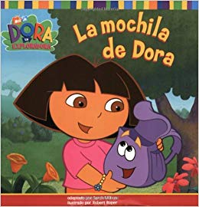

IV –Write each of the days of the week FIVE times. Yep. Five times.
_______________________ _______________________ _______________________
_______________________ _______________________ _______________________
_______________________ _______________________ _______________________
_______________________ _______________________ _______________________
_______________________ _______________________ _______________________

_______________________ _______________________ _______________________
_______________________ _______________________ _______________________
_______________________ _______________________ _______________________
_______________________ _______________________ _______________________
_______________________ _______________________ _______________________








