How to Create an Account and Enroll in a Course

- Go to www.vhlcentral.com.
- Click “Create an Account”. (If you already have an account, login and click on “Enroll in Course”. Then go to until Step 11.)
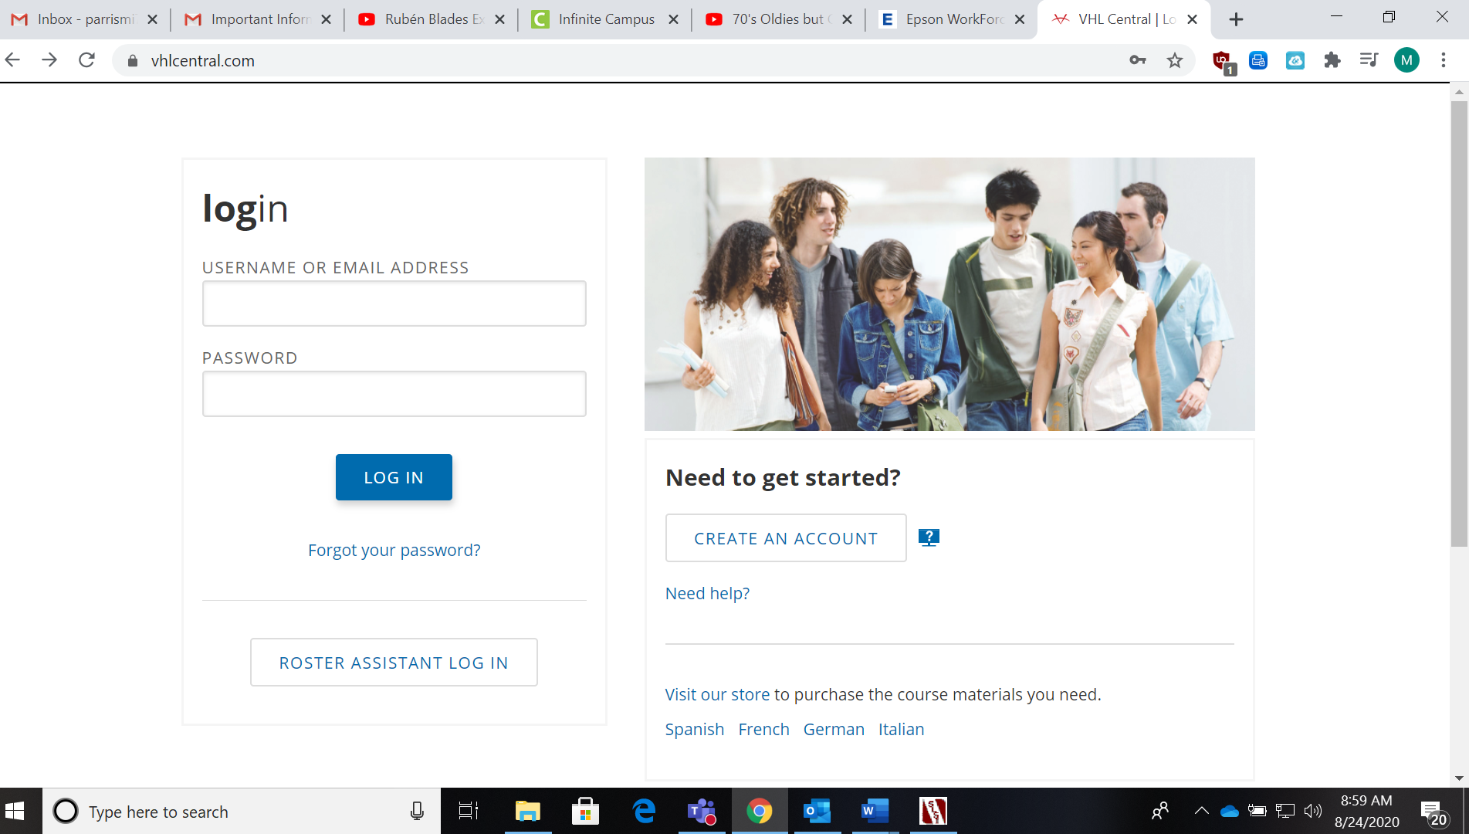
- For your username, USE YOUR SPANISH FIRST NAME and regular last name.
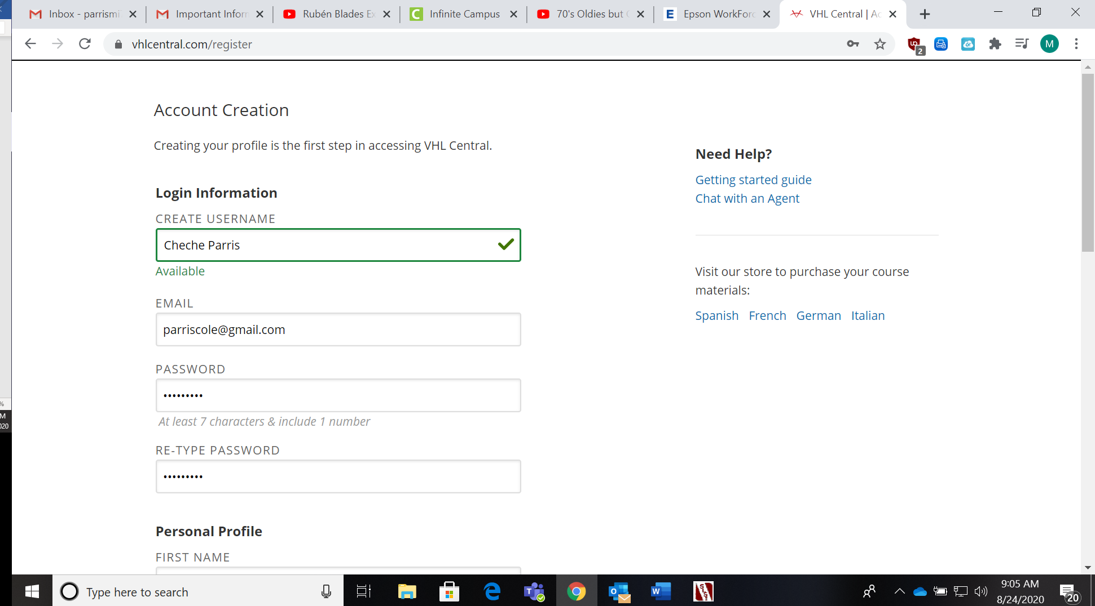
- For the email, do not use your Outlook email. Use a personal email address.

- WRITE DOWN YOUR USERNAME AND PASSWORD IN YOUR TEXTITO! People forgetting their password is the #1 problem my students have.
- Under “Personal Profile”, use your real name and give your birth year.
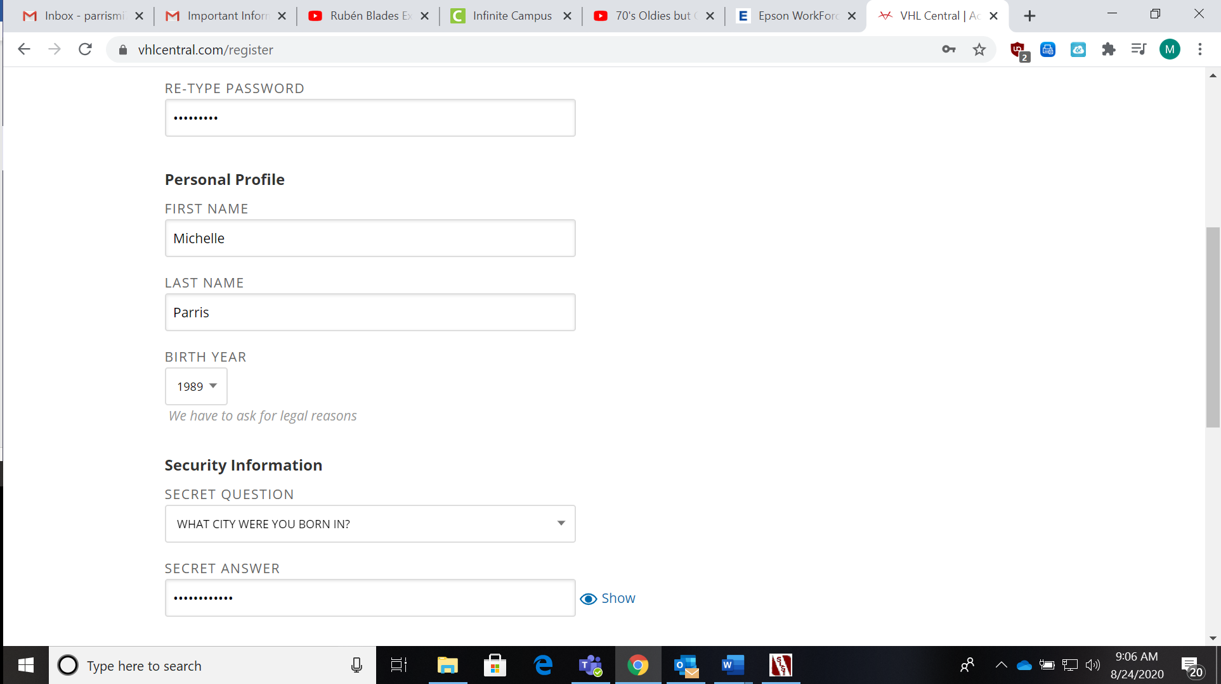
- Pick a security question and give an answer. Make sure you spell the secret answer correctly.

- DO NOT PICK ANY OF THE EMAIL PREFERENCES! Just click on “Continue”.
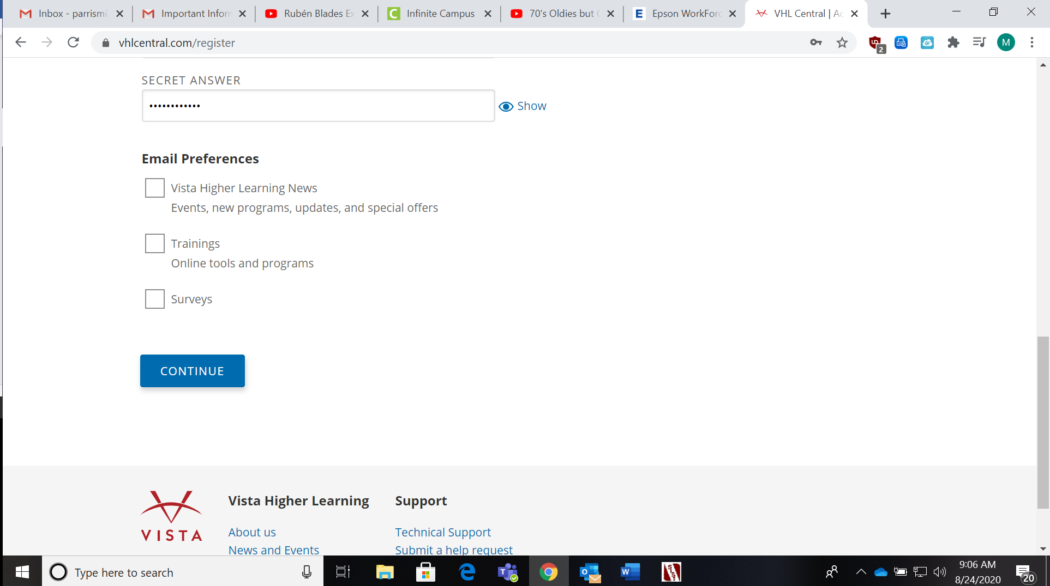
- Review to make sure all of your information is correct and click on “Create Account”. Then click on “Agree”.
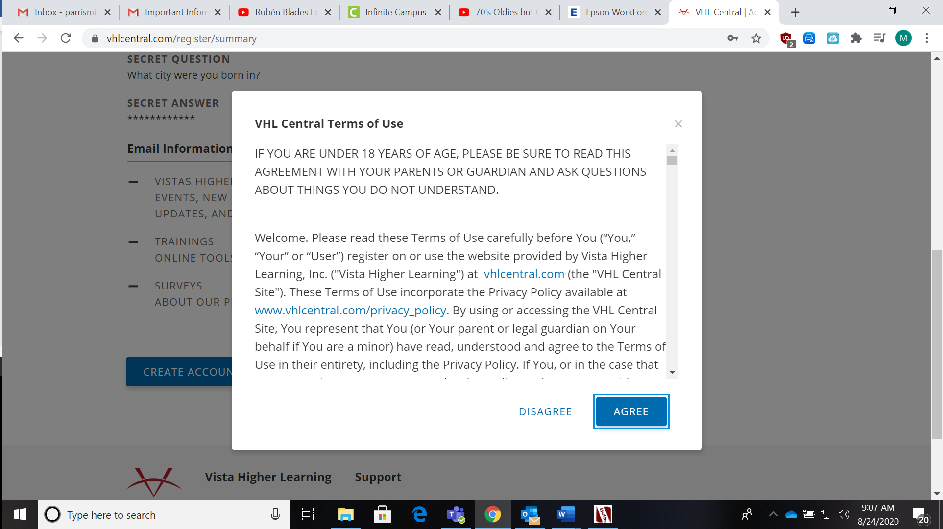
- In the search bar, type in “Alpharetta” and you will see our school come up as the first one. Select it and continue.
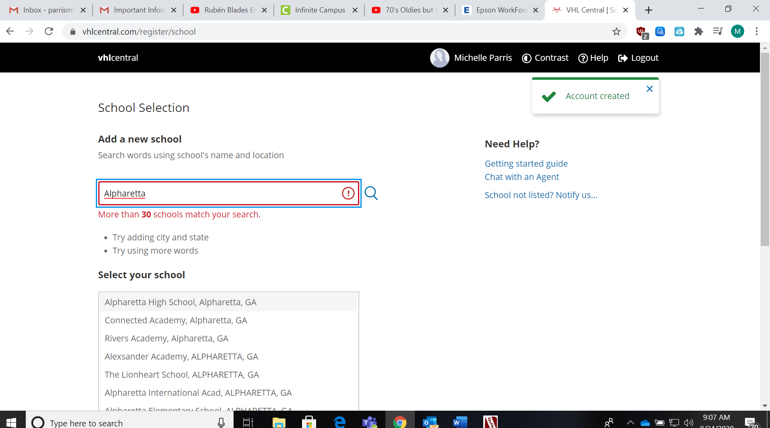

- Scroll down until you see the textbook “Descubre 1”. Click on it.
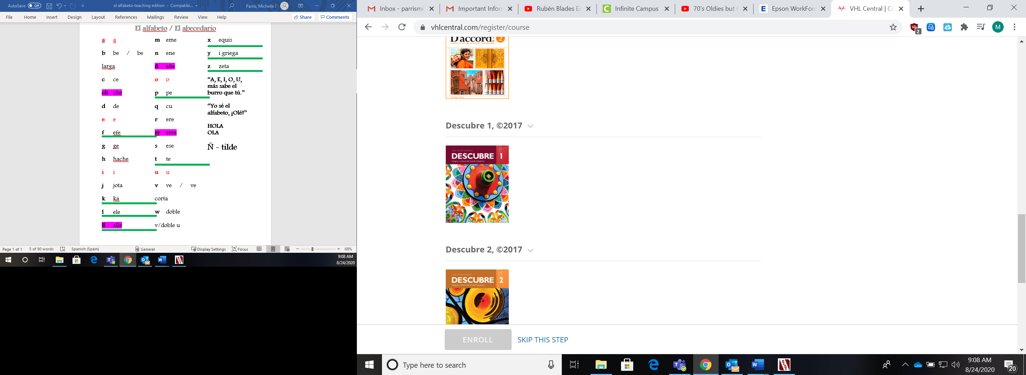
- Scroll down and look for my name (Estrada), SP1 for pds. 7 and 8, then the correct period. YOU MUST MAKE SURE YOU ENROLL IN THE CORRECT COURSE. Then click on “Enroll”.
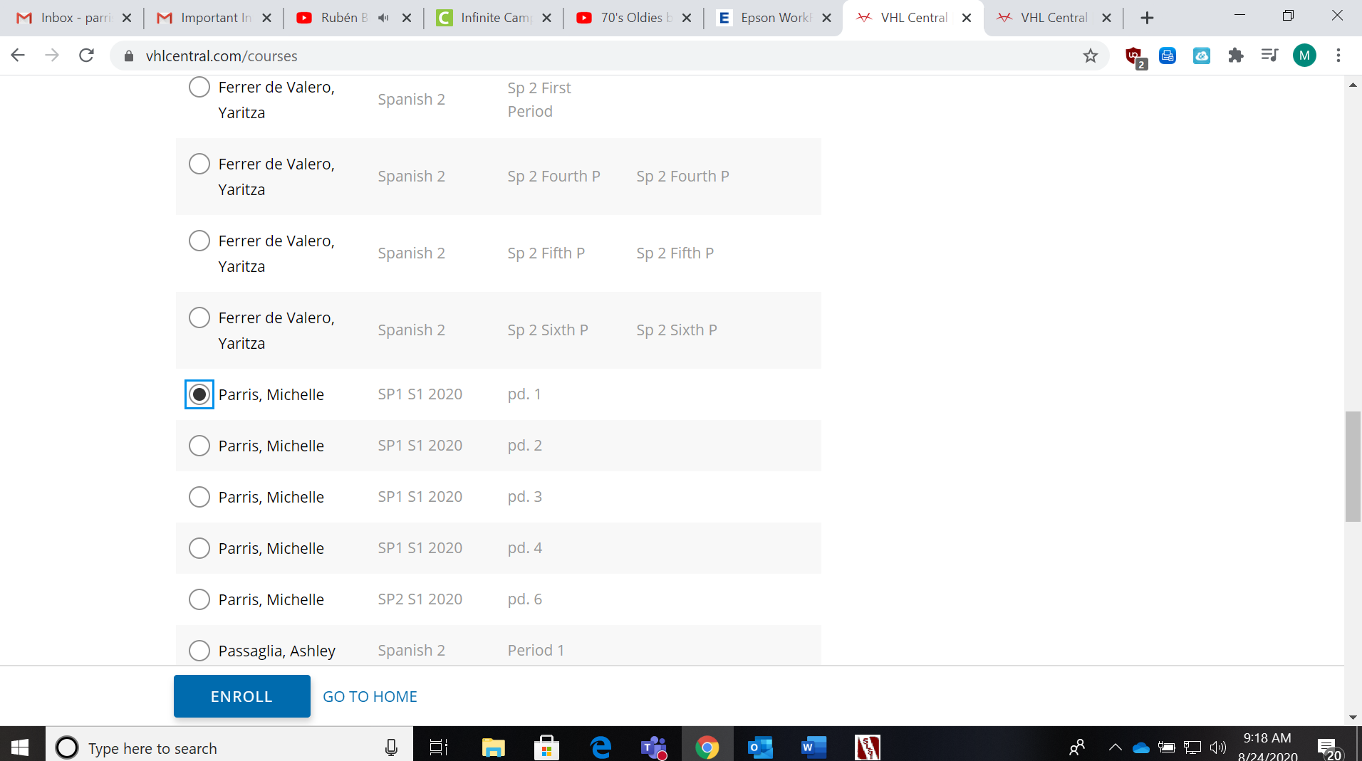
- Your screen should look like this. Click on the picture of the textbook.
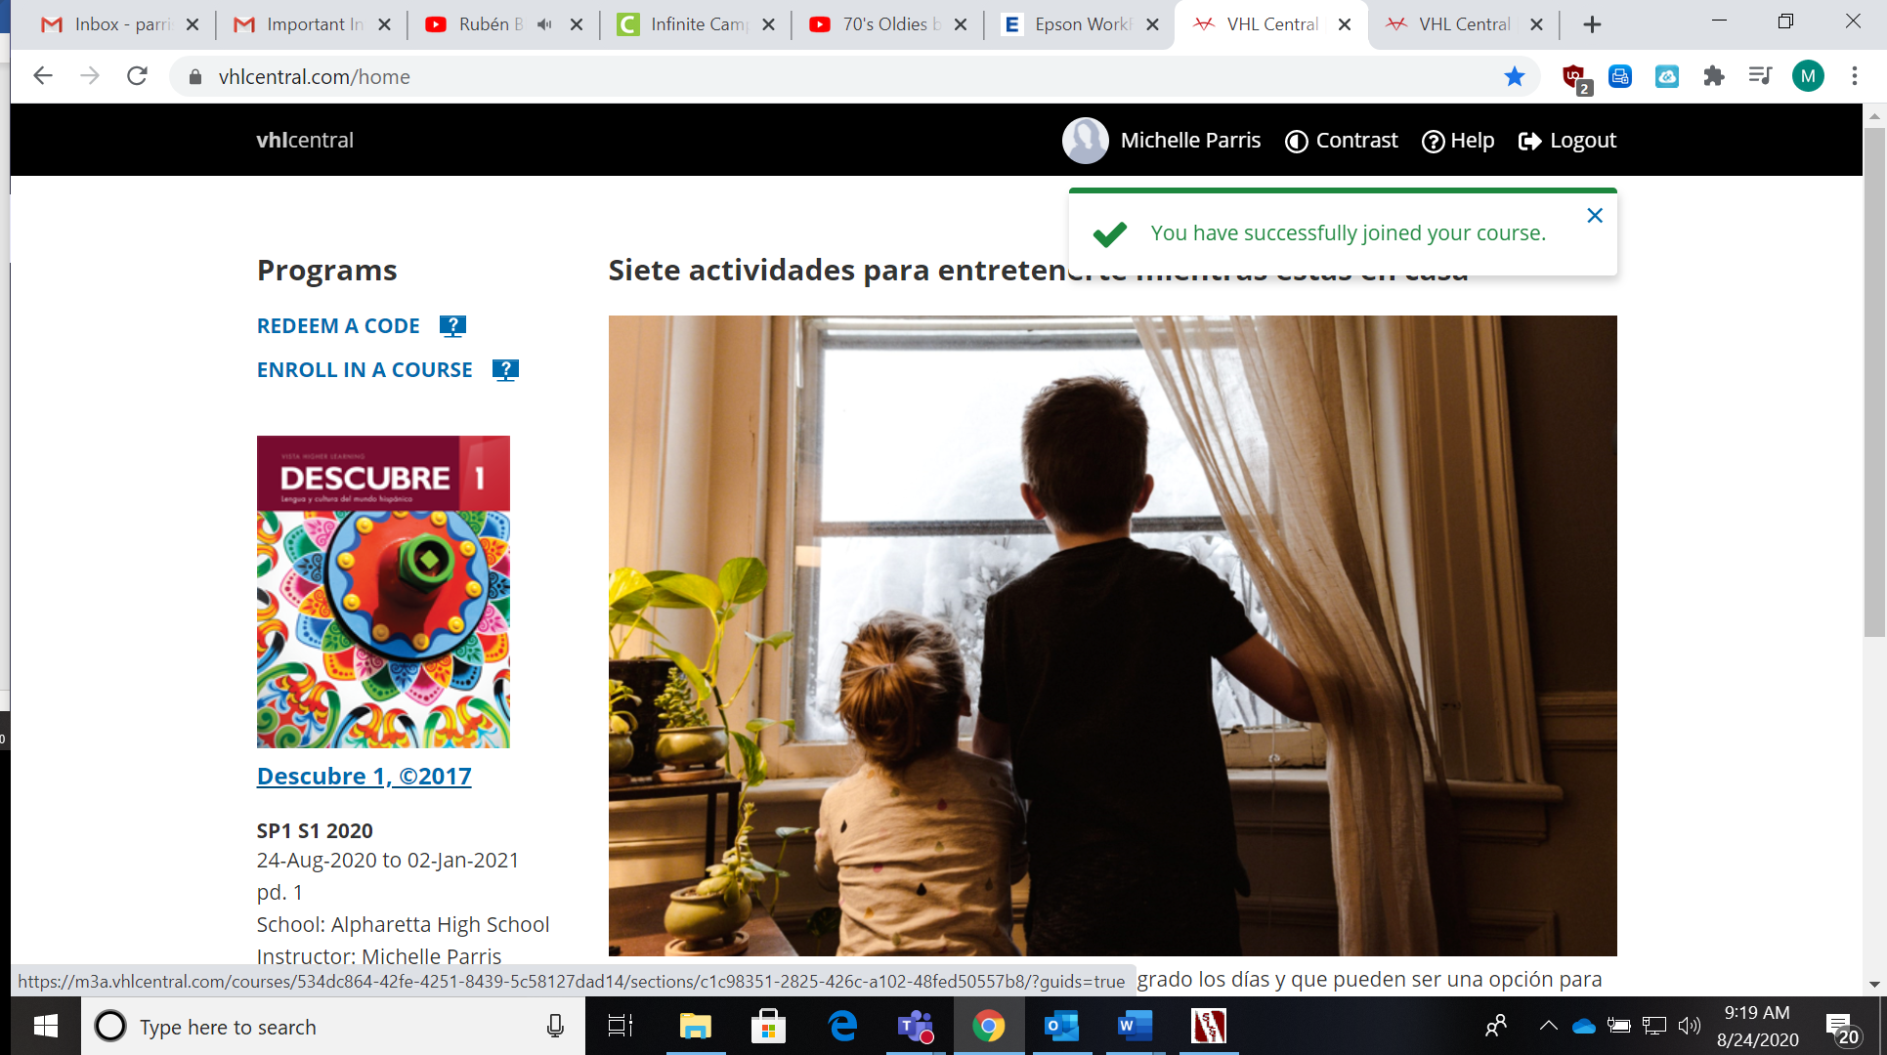

- The next screen you will see is called your dashboard. This is where you will see all of the work you need to complete. Click on “Start” and start practicing.
