Español 1 Nombre:_______________________

*Lección 2* Fecha:________________ Clase: ___

**¿Correcto o incorrecto?**

***Direcciones:*** Andrés and Marta are arguing about where certain places are in their city. Read where Andrés said the places are based on the map. If what he says is correct, circle C for *cierto*, but if he is wrong, circle F for *falso* AND rewrite the sentences so they make sense.

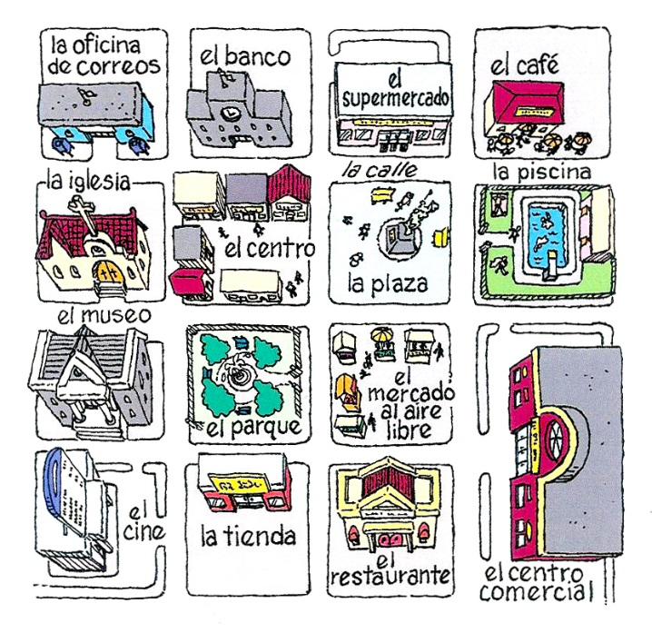

____ 1. La piscina está enfrente de la plaza.

_________________________________________________________________

____ 2. El banco está entre la plaza y la oficina de correos.

_________________________________________________________________

____ 3. La iglesia está a la derecha de la plaza.

_________________________________________________________________

____ 4. El restaurante está al lado del museo.

_________________________________________________________________

____ 5. La oficina de correos está cerca del centro comercial.

_________________________________________________________________

____ 6. El mercado está lejos del centro.

_________________________________________________________________

____ 7. El museo está entre la iglesia y el cine.

_________________________________________________________________

____ 8. El parque está detrás de la tienda.

_________________________________________________________________