AMDM Unit 4 Review—Using Recursion in Modeling and Decision Making Name________________________Pd____
Show your work for all problems. On the test, NO WORK = NO CREDIT!

Vocabulary:

Bivariate data
Scatterplot
Association
Cause-and-effect (causation)
Linear
Non-linear
Form
Direction
Strength
Explicit form
Recursive form
Linear function
Exponential function
Exponential Growth
Exponential Decay
Common difference
Common ratio
Growth rate
Growth factor
Trigonometry
Sine function
Cosine function
Periodic function
Amplitude
Period
Circumference

1. Consider the three graphs below.
a) Compare and contrast the graphs below with regard to form, strength and direction.
A B C
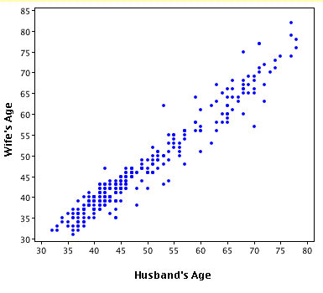
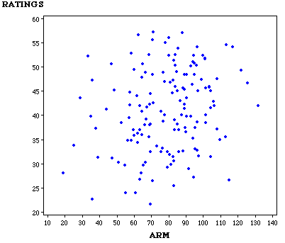
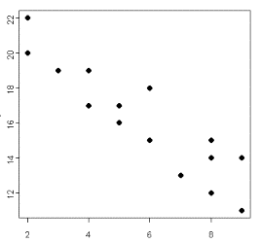
Time spent studying (hours per week)

Time spent playing video games (hours per week))

b) Of the three graphs, which could possibly have a cause-and-effect relationship between the variables? Why?

2. Describe the difference between an association and a cause-and-effect relationship and give an example of each.

3. Tell-All Phone Company charges a flat fee of $3.00 plus $0.20 per minute for international calls.
L
C
a) Let L represent the length of the phone call (in minutes) and C represent the total cost of a call (in dollars). Complete the table showing the cost of phone calls ranging from 0 to 9 minutes.
b) Which do the values in your table have, a common difference or a common ratio? What is it? What does this tell you about the type of function that would model the data?

c) Using the same variables from part (a), write a recursive function for the cost of a phone call lasting any number of minutes.

d) Using the same variables from part (a), write an explicit function for the cost of a phone call lasting any number of minutes.

e) Use your explicit function to predict the price of a 35-minute phone call.

f) What is the longest phone call you can make if you can spend up to $12?

4. Some studies show that each hour, the amount of caffeine remaining in your body is reduced by about 13%. Twelve ounces of Classic Coca-Cola has about 34 mg of caffeine.
a) What type of function best models this situation? (Make a table if that helps you answer the question)

b) Write a function that determines the amount of caffeine in your body after any number of hours.

c) If you drink a 12 oz. Coke at 3:00 pm, how much caffeine will be left in your body at 9:00 pm?
5. Assume that a basketball has a rebound percentage of 45%. Write both a recursive and explicit function to model the rebound height H_{N} in terms of the bounce number N. You can represent the initial height as H₀.
RECURSIVE: EXPLICIT:

6. Use one of your functions from #5 to find how high a basketball will bounce on the 6th bounce if it is dropped from a height of 25 feet. Explain why you chose the function you chose. Round your answer to the nearest hundredth.

7. a) Complete the table below.
x | y | Difference ( ∆y) | Ratio (y₂/y₁)
0 | 4.6 | ------------------------------- | -------------------------------
1 | 13.5
2 | 40.7
3 | 121
4 | 364.2
5 | 1094
6 | 3279.8

b) What type of function best models the data? Explain how you know.

c) Write a function to model the data.

8. The London Eye is a ferris wheel with a diameter of 120 meters and total height of 135 meters.
a) Draw a sketch of this ferris wheel. Be sure to include labels and units.

b) Find the circumference.

c) If the wheel rotates at about 30 minutes per revolution, how many degrees will it rotate in 1 minute?

d) How high off the ground will a capsule be after 2 minutes? After 5 minutes? After 20 minutes?

