L7.3 Preterito ser & ir
NOMBRE: __________________________________ FECHA: ________________________
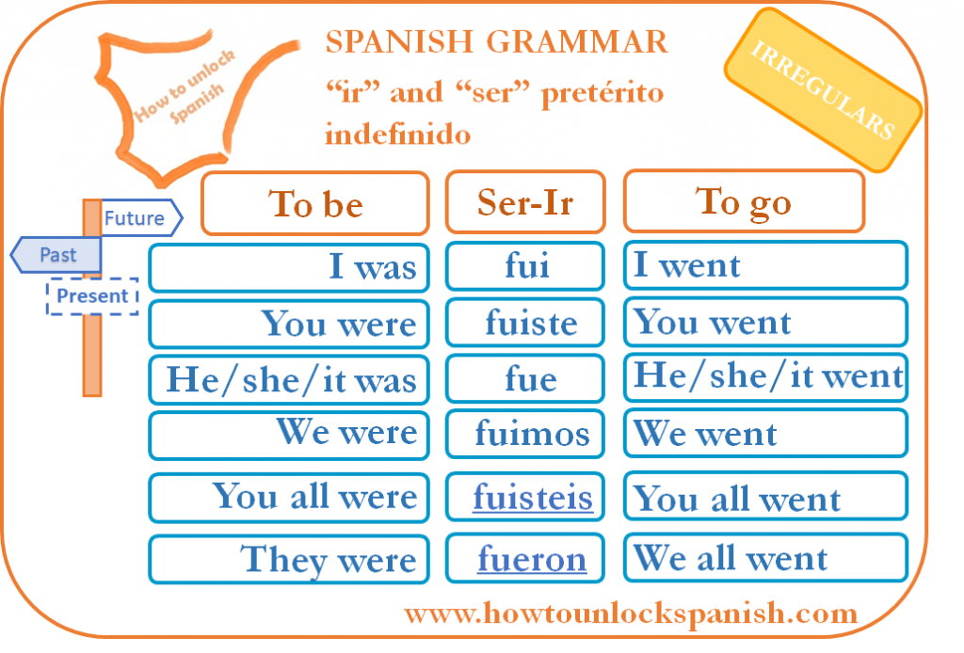
* Forma oraciones con estos elementos utilizando el pretérito.
A | B | C | D
Yo | (no) ir | a un restaurante | ayer
Tú | Ir | en autobús | anoche
Mi compañero | (no) ser | buen estudiante | anteayer
Nosotros | ser | muy simpático/a | la semana pasada
Mis amigos |  | a la playa | el año pasado
ustedes |  | dependiente/a en una tienda | el mes pasado

MODELO: Yo no fui a la playa anoche. / Anoche, yo no fui a la playa
1. __________________________________________________________________
2. __________________________________________________________________
3. __________________________________________________________________
4. __________________________________________________________________
5. __________________________________________________________________
** Traduce las siguientes oraciones utilizando el pretérito.
a) Last year I went to Spain for the holidays. We went by plane to Valencia and then we went to the hotel on Malvarrosa beach. On the third day, we went from Valencia to Ibiza on a boat. It was great.
b) When I went to Valencia you went to Barcelona. How was your trip? I think you went to a hotel in the center of the city and that your mother went with you.
c) Did you go to the Picasso museum? I went to the beach and to the shopping mall with my friends.
d) What did you do last weekend? I went to a restaurant, and I went to the park. Afterwards, I went to the cinema to watch a movie. It was fun.
e) When did you go to Toledo? I went to Toledo in January.
1. ___________________________________________________________________
2. ___________________________________________________________________
3. ___________________________________________________________________
4. ___________________________________________________________________
5. ___________________________________________________________________

**Completa las siguientes oraciones utilizando los verbos ser e ir en el pretérito.
a) Mi hermano___________ amigo de Carlos.
b) El verano pasado yo ________________ a España de vacaciones.
c) Las vacaciones ___________________ fenomenal. Lo pasé muy bien.
d) Tú _________ novio de Carmen durante tres años.
e) Mis amigos y yo __________________ al restaurante italiano para celebrar mi cumpleaños.

